Chapter 10, Problem 43.

Using the superposition principle, find i_{x} in the circuit of Fig. 10.88.

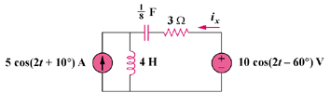

Figure 10.88
For Prob. 10.43.

